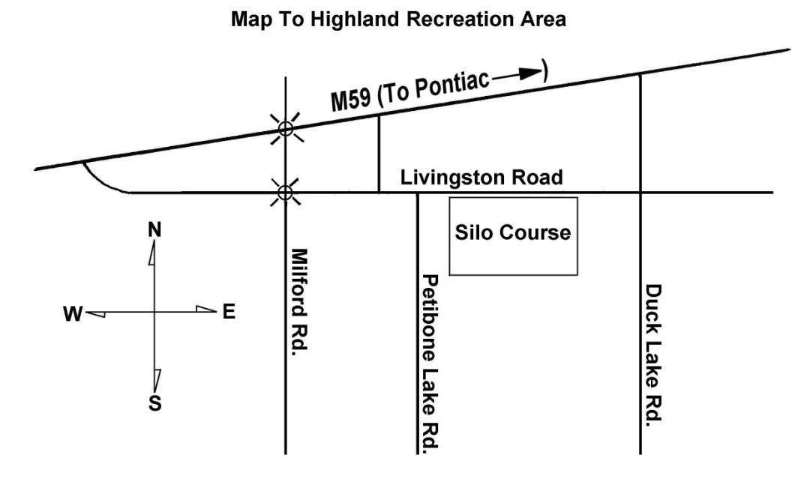

Best Western of Hartland, 1087 M59@ US23, Hartland, MI (810)632-7177

Kensington Inn, 124 Holiday LN, Howell, MI48843 (517)548-3510

Exit 137 off HWY I-96

Red Roof Inn, Farmington Hills, MI

HORSE Rental

Contact Will & Kathy Langley, Bottomcreek Farm, Will (810)338.8980

Kathy (810)338.0355 wklangley@yahoo.com

PARKING

A Michigan Motor Vehicle State Park Permit is required to park/camp on the grounds.

$9.00/day. Non-residents slightly higher.

CAMPING

State required camping fees are $10.00/night and are collected by the host club. No electric available, pump well for water.

Miscellaneous

There is potable water on the grounds by hand pump. Pavilion shelter and latrines on

the grounds. Restaurants, gas stations, grocery, etc., are on HWY M-59(about 3

miles from grounds)

# Southern Michigan Weimaraner Club

A.K.C. LICENSED FIELD TRIAL

**HIGHLAND RECREATION AREA, HIGHLAND, MICHIGAN**

**EVENT # 2018055207**

## May 19, 2018 – POINTING BREED WALKING FIELD TRIAL

**ALL STAKES OPEN TO ALL AKC REGISTERABLE POINTING BREEDS.**

**ALL STAKES ARE WALKING STAKES. NO HORSEBACK HANDLING.**

**ENTRIES LIMITED TO THE NUMBER OF DOGS WHICH CAN BE RUN DURING THE AVAILABLE DAY LIGHT HOURS AND ENTRIES WILL CLOSE WHEN THE LIMIT IS REACHED IF THAT OCCURS PRIOR TO SPECIFIED CLOSING TIME.**

**BITCHES IN SEASON MAY NOT COMPETE**

**This Trial will be run under the flexible format and the club reserves the right to rearrange the running order of the stakes and add/rearrange judges if conditions warrant**

This Field Trial is held under the Rules and Regulations of the

### AMERICAN KENNEL CLUB

MAIL ADVANCE ENTRIES WITH CHECKS MADE PAYABLE TO SMWC TO:

Mary Lester,5329 East C Ave., Richland, MI49083

ENTRIES WILL CLOSE AT 7:00 P.M. E.S.T, WEDNESDAY, MAY 16, 2018

NO TELEPHONE, FAX OR EMAIL ENTRIES. WAIVE SIGNATURE ON OVERNIGHTDELIEVERY.

DRAWING WILL TAKE PLACE AT 8:00 PM (EASTERN TIME), Wednesday, MAY 16,2018

AT 5329 East C Ave.,Richland, MI49083

### JUDGES AND STAKES TO BE JUDGED

Mike Braddock[Z1458]17126 W. Pleasant Lk. Rd.,Manchester,MI 48158

**Open Walking Gun Dog, Open Walking Puppy**

Blake Rizzo[95489] 3240 Auten Rd.,Ortonville,MI48042

**Open Walking Gun Dog, Open Walking Puppy,**

Sue DeGraw,15730 26 Mile Rd.,Macomb,MI48042

**AmateurWalking Gun Dog, Open Derby, Water Test**

Dan DeGraw15730 26 Mile Rd.,Macomb,MI48042

, **Amateur Walking Gun Dog, Open Derby,Water Test**

### FIELD TRIAL MARSHALS OFFICIAL GUNS

SMWC members

## STAKES, SCHEDULE AND ENTRY FEES

|  |  |  |
| --- | --- | --- |
|  | **Silo Course** |  |
| Open Walking Gun Dog | Not before 8:00 AM Local Time, Saturday., May 19, 2018 | $55.00 |
| Open Walking Derby | To Follow Open Walking Gun Dog | $45.00 |
| Open Walking Puppy | To Follow Open Walking Gun Dog | $45.00 |
| Amateur Walk Gun Dog | To Follow Open Walking Gun Dog | $55.00 |
| Water Test | To Follow Open Walking Gun Dog | $20.00 |

**The field trial committee reserves the right to change the running order should conditions warrant**

## COURSES AND BIRDS

ALL STAKES SINGLE COURSE WITHOUT BIRDFIELD

ALL STAKES ARE WALKING STAKES. NO HORSEBACK HANDLING.

QUAIL or CHUKAR RELEASED IN ALL STAKES

A BLANK CARTRIGE WILL ***NOT*** BE FIRED IN PUPPY STAKES SHOTGUNS WITH BLANK SHELLS WILL ***NOT*** BE PERMITTED IN ANY STAKE.

AKC APPROVED TRACKING COLLARS WILL BE PERMITTED AT THIS TRIAL

## PRIZES

STANDARD A.K.C. ROSETTES TO ALL PLACED DOGS

NEW CHAMPIONSHIP ROSETTES AWARDED

## CLUB OFFICERS

Darryl Yerrick President, 1222 108th, Otsego, MI49078

Bonnie Barden, Vice President, 56956 Stonewyck, Shelby Twp, MI 8316

Mary Lester, Secretary, 5329 East C Ave., Richland, MI 49083

Diane SuggSantoro Treasurer, 2500Barber Rd., Grass Lake, MI49240

## FIELD TRIAL COMMITTEE

Diane Santoro, Trial Chairman,

Mary Lester, Lee Santoro, TylerYerrick , Cliff Goodman, Keith Michalak

The SMWC is using State of MI grounds for this trial. We sincerely appreciate your participation in keeping the grounds clean. Please use designated areas for camping & parking. Please pick up after your animals and use available receptacles for refuse disposal.

All participants, guests and entries are accepted on the condition that the SMWC will not be held responsible for damage or injury sustained by people, dogs and/or horses in connection with or during the event.

|  |  |  |  |  |  |  |  |  |  |  |  |  |  |  |  |  |  |
| --- | --- | --- | --- | --- | --- | --- | --- | --- | --- | --- | --- | --- | --- | --- | --- | --- | --- |
| Telephone: | | | | | | Email Address: | | | | | | | | | | | |
| Club: **SOUTHERN MICHIGAN WEIMARANER CLUB** | | | | | | | | | | | | | | | | | |
| Location: **HIGHLAND RECREATION AREA, HIGHLAND, MICHIGAN** | | | | | | | | | | | | | | | | | |
| Date: | | | | | Event Number: | | | | | Event Type Test or Trial: | | | | | | | |
| May 19,2018 | | | | | 2018055207 | | | | | POINTING DOG FIELD TRIAL | | | | | | | |
| Enter in Stake/Test: | | | | | | | | | | | | | I enclose entry fees in the amount of: **$** | | | | |
| Breed: | | | | | | | Reg. #: | | | | | | | | Sex: | | Date of Birth: |
|  |  | AKC No. |  | AKC Litter No. | | | |  | ILP No. | |  | Foreign No.  & list country | | | | | |
| Full Name of Dog: | | | | | | | | | | | | | | | | Call Name: | |
| Sire: | | | | | | | | | | | | | | | | | |
| Dam: | | | | | | | | | | | | | | | | | |
| Name of Breeder: | | | | | | | | | | | | | | | | | |
| Name of Actual Owner(s): | | | | | | | | | | | | | | | | | |
| Owners Address: | | | | | | | | | | | | | | | | | |
| City: | | | | | | | | | | | | | | State: | | Zip: | |
| Name of Owner's Agent/Handler: | | | | | | | | | | | | | | | | | |
| AKC Rules, Regulations, Policies and Guidelines are available on the American Kennel Club website: **www.akc.orq**  **AGREEMENT**  I (we) agree that the club holding this event has the right to refuse this entry for cause, which the club shall deem sufficient. In consideration of the acceptance of this entry and of the holding of this event and of the opportunity to have the dog judged and to win prizes, ribbons, or trophies, I (we) agree to hold the AKC, the event-giving club, their members, directors, governors, officers, agents, superintendents or event secretary and the owner and/or lessor of the premises and any provider of services that are necessary to hold this event and any employees or volunteers of the aforementioned parties, and any AKC approved judge, judging at this event, harmless from any claim for loss or injury which may be alleged to have been caused directly or indirectly to any person or thing by the act of this dog while in or about the event premises or grounds or near any entrance thereto, and I (we) personally assume all responsibility and liability for any such claim; and I (we) further agree to hold the aforementioned parties harmless from any claim for loss, injury or damage to this dog.  Additionally, I (we) hereby assume the sole responsibility for and agree to Indemnify, defend and save the aforementioned parties harmless from any and all loss and expense (including legal fees) by reason of the liability imposed by law upon any of the aforementioned parties for damage because of bodily injuries, including death at any time resulting there from, sustained by any person or persons, including myself (ourselves), or on account of damage to property, arising out of or in consequence of my (our) participation in this event, however such, injuries, death or property damage may be caused, and whether or not the same  may have been caused or may be alleged to have been caused by the negligence of the aforementioned parties or any of their employees, agents, or any other persons. **I (WE) AGREE THAT ANY CAUSE OF ACTION, CONTROVERSY OR CLAIM ARISING OUT OF OR RELATED TO THE ENTRY, EXHIBITION OR ATTENDANCE AT THE EVENT BETWEEN THE AKC**  **AND MYSELF (OURSELVES) OR AS TO THE CONSTRUCTION, INTERPRETATION AND EFFECT OF THIS AGREEMENT**  **SHALL BE SETTLED BY ARBITRATION PURSUANT TO THE APPLICABLE RULES OF THE AMERICAN ARBITRATION**  **ASSOCIATION. HOWEVER, PRIOR TO ARBITRATION ALL APPLICABLE AKC BYLAWS, RULES, REGULATIONS AND PROCEDURES MUST FIRST BE FOLLOWED AS SET FORTH IN THE AKC CHARTER AND BYLAWS, RULES, REGULATIONS, PUBLISHED POLICIES AND GUIDELINES.** | | | | | | | | | | | | | | | | | |
| Signature of owner or his agent | | | | | | | | | | | | | | | | | |
| Address of Agent/Handler if different than Owner’s address: | | | | | | | | | | | | | | | | | |