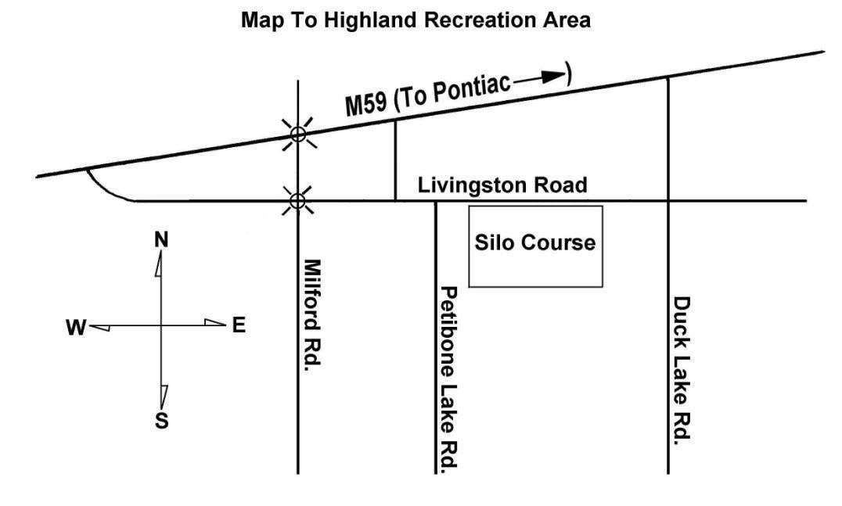

Best Western of Hartland, 1087 M59@ US23, Hartland, MI (810)632-7177

Kensington Inn, 124 Holiday LN, Howell, MI48843 (517)548-3510

Exit 137 off HWY I-96

Red Roof Inn, Farmington Hills, MI

PARKING

A Michigan Motor Vehicle State Park Permit is required to park/camp on the grounds. $9.00/day. Non-residents slightly higher.

CAMPING

State required camping fees are $10.00/night and are collected by the host club. No electric available, pump well for water.

Miscellaneous

There is potable water on the grounds by hand pump. Pavilion shelter and latrines on

the grounds. Restaurants, gas stations, grocery, etc., are on HWY M-59(about 3

miles from grounds)

# Southern Michigan Weimaraner Club

A.K.C. LICENSED FIELD TRIAL

**HIGHLAND RECREATION AREA, HIGHLAND, MICHIGAN**

**EVENT # 2019055208**

## May 18, 2019 – POINTING BREED WALKING FIELD TRIAL

**ALL STAKES OPEN TO ALL AKC REGISTERABLE POINTING BREEDS.**  **ALL STAKES ARE WALKING STAKES. NO HORSEBACK HANDLING.**

**ENTRIES LIMITED TO THE NUMBER OF DOGS WHICH CAN BE RUN DURING THE AVAILABLE DAY LIGHT HOURS AND ENTRIES WILL CLOSE WHEN THE LIMIT IS REACHED IF THAT OCCURS PRIOR TO SPECIFIED CLOSING TIME.**

### BITCHES IN SEASON MAY NOT COMPETE

**This Trial will be run under the flexible format and the club reserves the right to rearrange the running order of the stakes and add/rearrange judges if conditions warrant**

This Field Trial is held under the Rules and Regulations of the

### AMERICAN KENNEL CLUB

MAIL ADVANCE ENTRIES WITH CHECKS MADE PAYABLE TO SMWC TO:

Mary Lester,1613 Riverview, Kalamazoo, MI49004

ENTRIES WILL CLOSE AT 7:00 P.M. Local Time, WEDNESDAY, MAY 15, 2019

NO TELEPHONE, FAX OR EMAIL ENTRIES. WAIVE SIGNATURE ON OVERNIGHT DELIVERY.

DRAWING WILL TAKE PLACE AT 8:00 PM (EASTERN TIME), Wednesday, MAY 15, 2019

AT 1613 Riverview Dr.,Kalamazoo, MI49004

### JUDGES AND STAKES TO BE JUDGED

#### Lee Santoro, Jr.,[104259]2500BarberRd., Grass Lake, MI49240

#### Open Walking Gun Dog

Blake Rizzo[95489] 3240 Auten Rd.,Ortonville,MI48042

**Open Walking Gun Dog, Open Walking Puppy, Amateur Walking Gun Dog, Amateur Walking Puppy, Water test**

Dan DeGraw[45041] 15730 26MileRd., Macomb,MI48042

, **Amateur Walking Gun Dog, Open Puppy,Open Derby, Water Test**

### FIELD TRIAL MARSHALS /OFFICIAL GUNS

SMWC members

**STAKES, SCHEDULE AND ENTRY FEES**

**Silo Course**

Open Walking Gun Dog Not before 8:00 AM Local Time, $55.00

Saturday., May 19, 2018

Open Walking Derby To Follow Open Walking Gun Dog $50.00

Open Walking Puppy To Follow Open Walking Gun Dog $50.00

Amateur Walk Gun Dog To Follow Open Walking Gun Dog $55.00

Water Test To Follow Open Walking Gun Dog $20.00

**The field trial committee reserves the right to change the running order should conditions warrant**

## COURSES AND BIRDS

ALL STAKES SINGLE COURSE WITHOUT BIRDFIELD

ALL STAKES ARE WALKING STAKES. NO HORSEBACK HANDLING.

QUAIL or CHUKAR RELEASED IN ALL STAKES

A BLANK CARTRIGE WILL ***NOT*** BE FIRED IN PUPPY STAKES

SHOTGUNS WITH BLANK SHELLS WILL ***NOT*** BE PERMITTED IN ANY STAKE.

AKC APPROVED TRACKING COLLARS WILL BE PERMITTED AT THIS TRIAL

## PRIZES

STANDARD A.K.C. ROSETTES TO ALL PLACED DOGS

NEW CHAMPIONSHIP ROSETTES AWARDED

## CLUB OFFICERS

Darryl Yerrick President, 1222 108th, Otsego, MI49078

Bonnie Barden, Vice President, 56956 Stonewyck, Shelby Twp, MI 8316

Mary Lester, Secretary, 5329 East C Ave., Richland, MI 49083

Diane SuggSantoro Treasurer, 2500Barber Rd., Grass Lake, MI49240

## FIELD TRIAL COMMITTEE

Diane Santoro, Trial Chairman,

Mary Lester, Lee Santoro, TylerYerrick , Cliff Goodman, Keith Michalak

The SMWC is using State of MI grounds for this trial. We sincerely appreciate your

participation in keeping the grounds clean. Please use designated areas for camping & parking.

Please pick up after your animals and use available receptacles for refuse disposal.

All participants, guests and entries are accepted on the condition that

the SMWC will not be held responsible for damage or injury sustained by people,

dogs and/or horses in connection with or during the event.

OFFICIAL AMERICAN KENNEL CLUB ENTRY FORM

# **2019055208**

*Note: This Entry Form Must Be Completed in Full*

**FOR FIELD TRIALS / HUNTING TESTS**

***SOUTHERN MICHIGAN WEIMARANER CLUB, INC***

**HIGHLAND RECREATION AREA,HIGHLAND, MICHIGAN**

**May 18, 2019**

**Event # 2019055208**

|  |  |  |  |  |  |
| --- | --- | --- | --- | --- | --- |
| Foreign No.  **X** AKC No. AKC Litter No. ILP No. & list country: | | | I enclose entry fees  In the amount of : $ | | Stake: |
| Full Name of Dog: | | | | | |
| Breed: | Reg. #: | Call Name : | | Sex: | Date of Birth: |
| Sire: | | | | | |
| Dam: | | | | | |
| Name of Breeder: | | | | | |
| Actual owner(s): | | | | | |
| Owner’s Address: | | | | | |
| City: State: Zip: | | | | | |
| Name of Owner’s Agent/Handler: | | | | | |
| Agent/Handler’s Address: | | | | | |
| City: State: Zip: | | | | | |
| AKC Rules, Regulations, Policies and Guidelines are available on the American Kennel Club website:**www.akc.org**  **AGREEMENT**  I certify that I am the actual owner of the dog, or that I am the duly authorized agent of the actual owner whose name I have entered  above. In consideration of the acceptance of this entry, I (we) agree to abide by the rules and regulations of The American Kennel Club in effect at the time of this event, and any additional rules and regulations appearing in the premium list of this event and entry form and any  decision made in accord with them. I (we) agree that the club holding this event has the right to refuse this entry for cause which the club  shall deem sufficient. In consideration of the acceptance of this entry and of the holding of this event and of the opportunity to have the  dog judged and to win prizes, ribbons, or trophies, I (we) agree to hold the AKC, the event-giving club, their members, directors, governors, officers, agents, superintendents or event secretary and the owner and/or lessor of the premises and any provider of services that are necessary to hold this event and any employees or volunteers of the aforementioned parties, and any AKC approved judge, judging at this event, harmless from any claim for loss or injury which may be alleged to have been caused directly or indirectly to any person or thing by the act of this dog while in or about the event premises or grounds or near any entrance thereto, and I (we) personally assume all  responsibility and liability for any such claim; and I (we) further agree to hold the aforementioned parties harmless from any claim for loss,  injury or damage to this dog. Additionally, I (we) hereby assume the sole responsibility for and agree to indemnify, defend and save the  aforementioned parties harmless from any and all loss and expense (including legal fees) by reason of the liability imposed by law upon  any of the aforementioned parties for damage because of bodily injuries, including death at any time resulting therefrom, sustained by any  person or persons, including myself (ourselves), or on account of damage to property, arising out of or in consequence of my (our)  participation in this event, however such, injuries, death or property damage may be caused, and whether or not the same may have been  caused or may be alleged to have been caused by the negligence of the aforementioned parties or any of their employees, agents, or any  other persons.  I (WE) AGREE THAT ANY CAUSE OF ACTION, CONTROVERSY OR CLAIM ARISING OUT OF OR RELATED TO THE ENTRY, EXHIBITION OR ATTENDANCE AT THE EVENT BETWEEN THE AKC AND THE EVENT-GIVING CLUB (UNLESS OTHERWISE STATED IN TIS PREMIUM LIST) AND MYSELF (OURSELVES) OR AS TO THE CONSTRUCTION, INTERPRETATION AND EFFECT OF THIS AGREEMENT SHALL BE SETTLED BY ARBITRATION PURSUANT TO THE APPLICABLE RULES OF THE AMERICAN ARBITRATION ASSOCIATION. HOWEVER, PRIOR TO ARBITRATION ALL APPLICABLE AKC BYLAWS, RULES, REGULATIONS AND PROCEDURES MUST FIRST BE FOLLOWED AS SET FORTH IN THE AKC CHARTER AND BYLAWS, RULES, REGULATIONS, PUBLISHED POLICIES AND GUIDELINES. | | | | | |
| Signature of owner or his  Agent duly authorized to make this entry | | | | | |
| **Telephone:** **Email:** | | | | | |