**AKC– POINTING BREEDS HUNT TEST & FIELD TRIAL JUDGES’ SEMINARS**

**Hosted by Michigan Brittany Club**

**Presented by Tom Maneely, AKC Performance Representative**

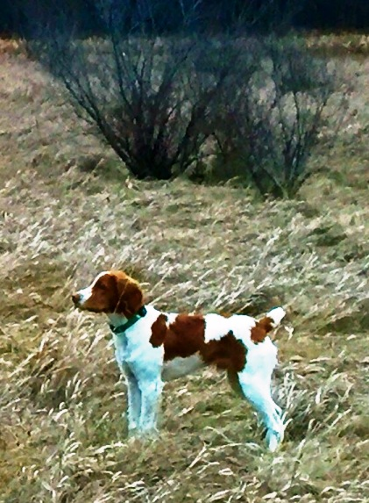**HUNT TEST:**

When: Saturday, June 9, 2018 from 9 a.m. - 5 p.m.

Where: 3130 Pine Tree Road, Lansing, MI

Cost: $35/ person

**FIELD TRIAL:**

When: Sunday, June 10, from 9 a.m. - 5 p.m.

Where: 3130 Pine Tree Road, Lansing, MI

Cost: $35/person

**WHO SHOULD ATTEND:**

Prospective judges

Hunt test judges who have not taken a seminar or passed a written test in five years

Those who want to brush up on the rules

Those who want to discuss “what if” or “personally handled or judged” situations

Those who want to talk shop with fellow passionate dog handlers & judges

**(At AKC’s request, please do not bring your dogs to the seminar.)**

**In a Senior hunt test, if a dog blinks the dog on point can the handler verbally command his/her dog to honor?**

**In a Gun Dog field trial, is a dog picked up for failure to honor?**

**DIRECTIONS AND NEARBY HOTELS:**

The seminar is located near the intersection of I-96 and US-127 in Lansing, MI. Directions will be provided upon request and/or receipt of a paid registration.

Mention Michigan Concrete Association when reserving a hotel and receive a discounted rate.

Candlewood Suites, 3545 Forest Road, East Lansing, MI, 517-351-8181 (five minutes away)

Fairfield Inn-Marriott, 2335 Woodlake Drive, Okemos, MI, 517-347-1000 (less than ten minutes away)

***Seminar fee must be in hand prior to the requested date.***

Please complete and mail the below information to Kim McVeigh, 21639 Connemara Drive, Northville, MI 48167.

Make checks out to Michigan Brittany Club. Reservation(s) must be received no later than Saturday, May 26, 2018.

Email questions to [jazzbuster@earthlink.net](mailto:jazzbuster@earthlink.net) or call Kim at 248-345-4142 (Please leave a voice mail message.)

-------------------------------------------------------------------------------------------------------------------------------------------------------------------------------------------------------------------------------------------------------

**HUNT TEST SEMINAR ($35)** **FIELD TRIAL SEMINAR ($35)**

Name __________________________________________________ Email ________________________________________

Address _________________________________________________________________________________________________

Cell Phone ______________________________________________ Home Phone __________________________________

***Lunch may only be pre-ordered for an additional fee of $10.00 per day. Lunch will be a working lunch and provided by Panera Bread [sandwich/chips/pickle/cookie with mayo and spicy mustard on the side plus a drink (pop or water)].***

Saturday Lunch Ham & Swiss Mediterranean Veggie Tuna Salad Turkey Sierra Turkey

Sunday Lunch Ham & Swiss Mediterranean Veggie Tuna Salad Turkey Sierra Turkey







Amount Enclosed: Seminar(s) $_________ Lunch(es) $_________ Donation $_________ Total Enclosed $_________

***ALL PROFITS WILL GO TOWARDS THE BETTERMENT OF***

***THE HIGHLAND FIELD TRIAL GROUNDS, SILO COURSE, HIGHLAND, MI***